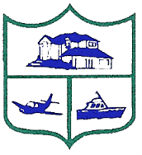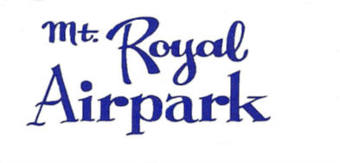

ANNUAL MEMBERSHIP MEETING

MT. ROYAL AIRPARK PAVILION
109 Airport Drive
Crescent City, FL 32112
March 23, 2024
10:00 a.m.
Meeting Agenda

BOARD MEMBERS PRESENT: BOARD MEMBERS AT LARGE:
Tom Cacek, President David Johnston
Jeff Sager, Vice-President Jeff Levine
Monique Glaize, Secretary-Treasurer Bob Welsh
Rebecca Poston, Assistant Secretary (nonvoting) Dave Zawistowski

- Introductions/Opening Remarks/Call to Order Tom Cacek
- Call of Role and Certification of Quorum
- Proof of Meeting Notice
- Total Count for Lunch
- Member Introductions

- Presentations Tom Cacek
  - Honorable H.D. “Gator” DeLoach, Putnam County Sheriff
  - Greg Workman, Regional Director, Florida Fish and Wildlife

- Meeting Minutes Approval Tom Cacek
      - Approval of 3/11/2023 Meeting Minutes

- Officer and Committee Updates Tom Cacek
      - President Report of Board Activities- Tom Cacek
      - Treasurer’s Report- Monique Glaize
      - Reserve Fund Committee Update- Tom Cacek
      - Architectural Review Board Update- Karen Sager
      - Covenants and Restrictions Committee Update- Jeff Sager
      - Covenants and Restrictions Violations- Tom Cacek
      - Aviation Committee Update- Kevin Poston
      - East and West Dock Committee Update- Dave Zawistowski / Dave Houchin
      - Legislative Update- Becki Poston
      - Submerged Land Lease Update- Janet Simoneaux

- Election of Directors Tom Cacek
      - Candidate Introduction
      - Election of Directors
  - Monique Glaize
  - David Johnston

- New Business Tom Cacek
A. Mount Royal Common Property Report- Joe Miller, Steve Simoneaux
B. Mount Royal Estates Homeowners’ Association- Janet Kleinsmith, President
- Open Discussion

- Adjournment

